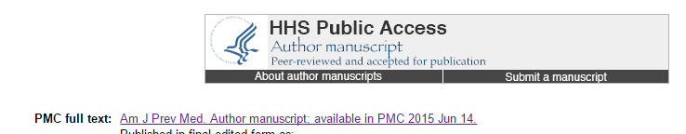

An external file that holds a picture, illustration, etc.
Object name is nihms59469f2.jpg

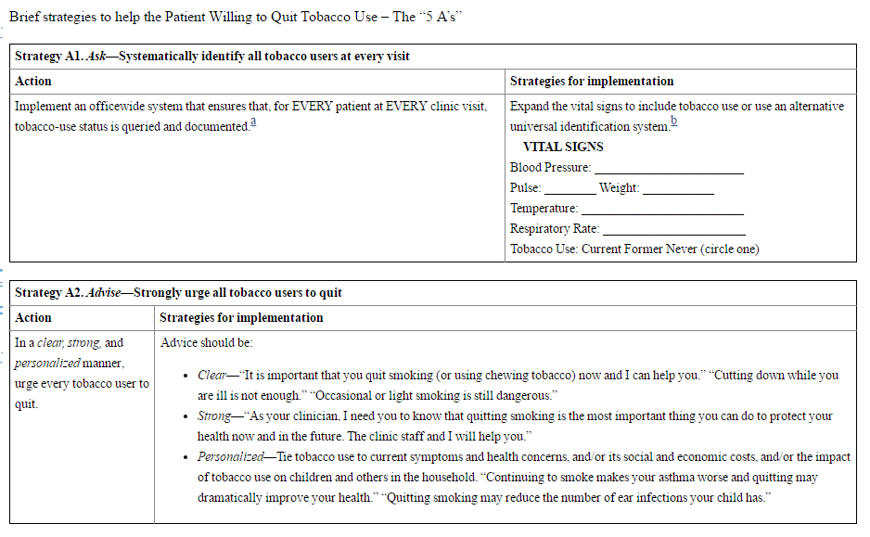

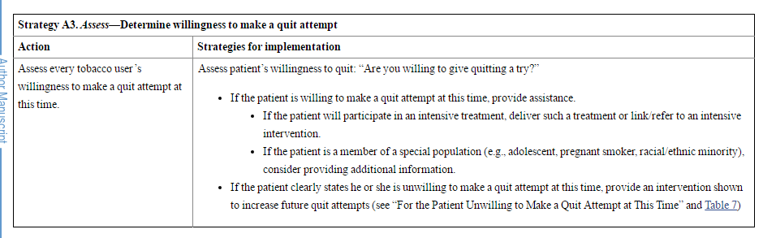

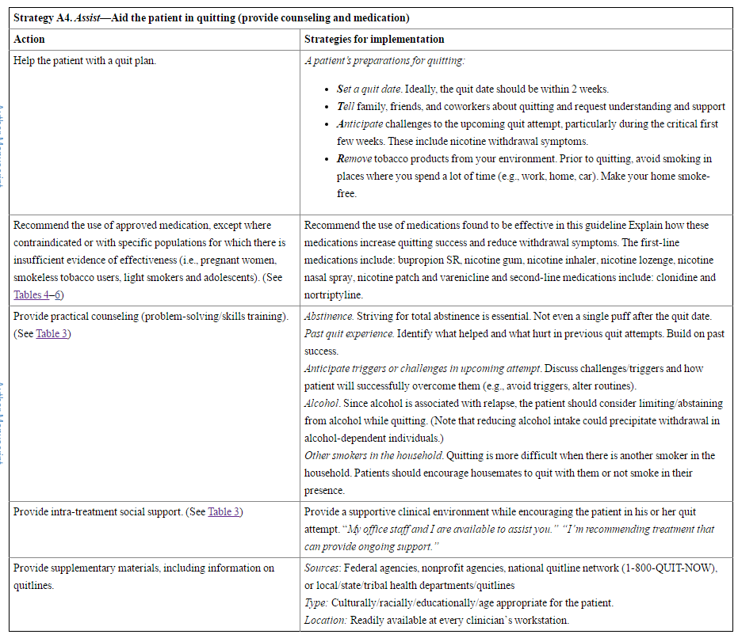

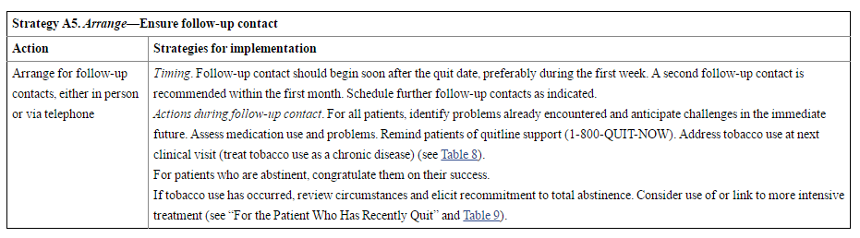

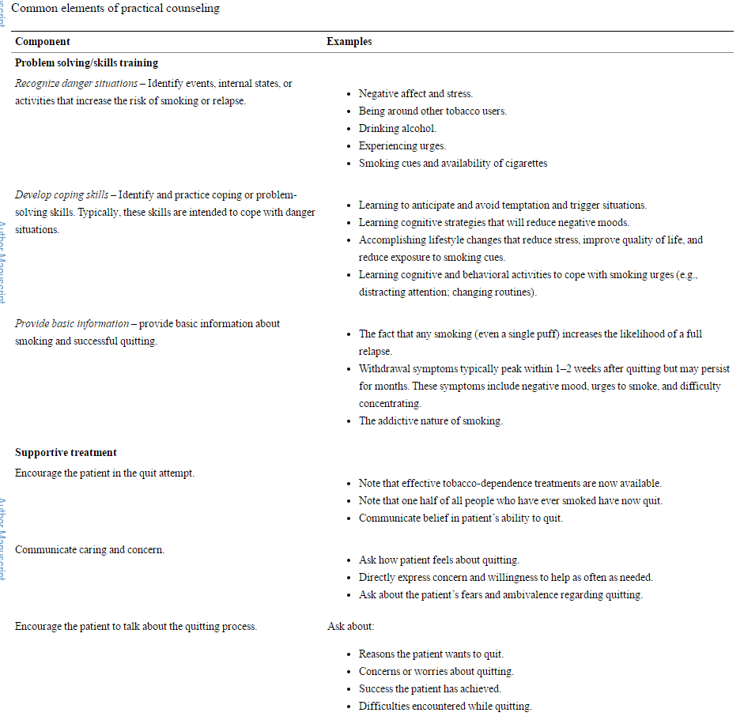

General clinical guidelines for prescribing medication for treating tobacco use and dependence

|  |  |
| --- | --- |
| Who should receive medication for tobacco use? Are there groups of smokers for whom medication has not been shown to be effective? | All smokers trying to quit should be offered medication, except where contraindicated or for specific populations for which there is insufficient evidence of effectiveness (i.e., pregnant women, smokeless tobacco users, light smokers and adolescents) |
| What are the first-line medications recommended in this guideline update? | All seven of the FDA-approved medications for treating tobacco use are recommended: bupropion SR, nicotine gum, nicotine inhaler, nicotine lozenge, nicotine nasal spray, the nicotine patch and varenicline. The clinician should consider the first-line medications shown to be more effective than the nicotine patch alone: 2 mg/day varenicline or the combination of long-term nicotine patch use + ad libitum NRT. Unfortunately, there are no well accepted algorithms to guide optimal selection among the first-line medications. |
| Are there contraindications, warnings, precautions, other concerns, and side effects regarding the first-line medications recommended in this guideline Update? | All seven FDA-approved medications have specific contraindications, warnings, precautions, other concerns, and side effects. Please refer to FDA package inserts for this complete information and FDA updates and to the individual drug tables in the 2008 Update and [Table 5](https://www.ncbi.nlm.nih.gov/pmc/articles/PMC4465757/table/T5/). (See information below regarding second-line medications.) |
| What other factors may influence medication selection? | Pragmatic factors may also influence selection such as insurance coverage or out-of-pocket patient costs, likelihood of adherence, dentures when considering the gum, or dermatitis when considering the patch. |
| Is a patient’s prior experience with a medication relevant? | Prior successful experience (sustained abstinence with the medication) suggests that the medication may be helpful to the patient in a subsequent quit attempt, especially if the patient found the medication to be tolerable and/or easy to use. However, it is difficult to draw firm conclusions from prior failure with a medication. Some evidence suggests that retreating relapsed smokers with the same medication produces small or no benefit[52](https://www.ncbi.nlm.nih.gov/pmc/articles/PMC4465757/#R52),[53](https://www.ncbi.nlm.nih.gov/pmc/articles/PMC4465757/#R53) while other evidence suggests that it may be of substantial benefit.[54](https://www.ncbi.nlm.nih.gov/pmc/articles/PMC4465757/#R54) |
| What medications should a clinician use with a patient who is highly nicotine dependent? | The higher dose preparations of nicotine gum, patch, and lozenge have been shown to be effective in highly dependent smokers.[55](https://www.ncbi.nlm.nih.gov/pmc/articles/PMC4465757/#R55)–[57](https://www.ncbi.nlm.nih.gov/pmc/articles/PMC4465757/#R57) Also, there is evidence that combination NRT therapy may be particularly effective in suppressing tobacco withdrawal symptoms.[58](https://www.ncbi.nlm.nih.gov/pmc/articles/PMC4465757/#R58),[59](https://www.ncbi.nlm.nih.gov/pmc/articles/PMC4465757/#R59) Thus it may be that NRT combinations are especially helpful to highly dependent smokers or those with a history of severe withdrawal. |
| Is gender a consideration in selecting a medication? | There is evidence that NRT can be effective with both genders[60](https://www.ncbi.nlm.nih.gov/pmc/articles/PMC4465757/#R60)–[62](https://www.ncbi.nlm.nih.gov/pmc/articles/PMC4465757/#R62); however, evidence is mixed as to whether NRT is less effective in women than men.[63](https://www.ncbi.nlm.nih.gov/pmc/articles/PMC4465757/#R63)–[67](https://www.ncbi.nlm.nih.gov/pmc/articles/PMC4465757/#R67) This may encourage the clinician to consider use of another type of medication with women such as bupropion SR or varenicline. |
| Are cessation medications appropriate for light smokers (i.e., <10 cigarettes/day)? | As noted above, cessation medications have not been extensively evaluated in light smokers. However, if NRT is used with light smokers, clinicians may consider reducing the dose of the medication. No adjustments are necessary when using bupropion SR or varenicline. |
| When should second-line agents be used for treating tobacco dependence? | Consider prescribing second-line agents (clonidine and nortriptyline) for patients unable to use first-line medications because of contraindications or for patients for whom the group of first-line medications has not been helpful. Assess patients for the specific contraindications, precautions, other concerns, and side effects of the second-line agents. Please refer to FDA package inserts for this information and to the individual drug tables in the 2008 Update. |
| Which medications should be considered with patients particularly concerned about weight gain? | Data show that bupropion SR and nicotine replacement therapies, in particular 4 mg nicotine gum and 4 mg nicotine lozenge, delay, but do not prevent, weight gain. |
| Are there medications that should be especially considered in patients with a past history of depression? | Bupropion SR and nortriptyline appear to be effective with this population,[68](https://www.ncbi.nlm.nih.gov/pmc/articles/PMC4465757/#R68)–[72](https://www.ncbi.nlm.nih.gov/pmc/articles/PMC4465757/#R72) but nicotine replacement medications also appear to help individuals with a past history of depression. |
| Should nicotine replacement therapies be avoided in patients with a history of cardiovascular disease? | No. The nicotine patch in particular has been demonstrated as safe for cardiovascular patients. See individual drug tables in 2008 Update and FDA package inserts for more complete information. |
| May tobacco-dependence medications be used long-term (e.g., up to 6 months)? | Yes. This approach may be helpful with smokers who report persistent withdrawal symptoms during the course of medications, who have relapsed in the past after stopping medication, or who desire long-term therapy. A minority of individuals who successfully quit smoking use ad libitum NRT medications (gum, nasal spray, inhaler) long-term. The use of these medications for up to 6 months does not present a known health risk and developing dependence on medications is uncommon. Additionally, the FDA has approved the use of bupropion SR, varenicline and some NRT medications for 6 month use. |
| Is medication adherence important? | Yes. Patients frequently do not use cessation medications as recommended (e.g., they don’t use them at recommended doses or for recommended durations) and this may reduce their effectiveness. |
| May medications ever be combined? | Yes. Among first-line medications, evidence exists that combining the nicotine patch long-term (> 14 weeks) with either nicotine gum or nicotine nasal spray, the nicotine patch with the nicotine inhaler, or the nicotine patch with bupropion SR, increases long-term abstinence rates relative to placebo treatments. Varenicline is not recommended in combination with NRT. |

In summary, the tobacco guideline update panel’s major conclusions and recommendations are:

1. Tobacco dependence is a chronic disease that often requires repeated intervention and multiple attempts to quit. However, effective treatments exist that can significantly increase rates of long-term abstinence.
2. It is essential that clinicians and healthcare delivery systems consistently identify and document tobacco-use status and treat every tobacco user seen in a healthcare setting.
3. Tobacco dependence treatments are effective across a broad range of populations. Clinicians should encourage every patient willing to make a quit attempt to use the counseling treatments and medications recommended in this guideline.
4. Brief tobacco-dependence treatment is effective. Clinicians should offer every patient who uses tobacco at least the brief treatments shown to be effective in this guideline.
5. Individual, group, and telephone counseling are effective and their effectiveness increases with treatment intensity. Two components of counseling are especially effective and clinicians should use these when counseling patients making a quit attempt:
   * Practical counseling (problem-solving/skills training)
   * Social support delivered as part of treatment
6. There are numerous effective medications for tobacco dependence, and clinicians should encourage their use by all patients attempting to quit smoking, except when medically contraindicated or with specific populations for which there is insufficient evidence of effectiveness (i.e., pregnant women, smokeless tobacco users, light smokers, and adolescents).
   * Seven first-line medications (five nicotine and two non-nicotine) reliably increase long-term smoking abstinence rates:
     + Bupropion SR
     + Nicotine gum
     + Nicotine inhaler
     + Nicotine lozenge
     + Nicotine nasal spray
     + Nicotine patch
     + Varenicline
   * Clinicians should also consider the use of certain combinations of medications identified as effective in this guideline.
7. Counseling and medication are effective when used by themselves for treating tobacco dependence. However, the combination of counseling and medication is more effective than either alone. Thus, clinicians should encourage all individuals making a quit attempt to use both counseling and medication.
8. Telephone quitline counseling is effective with diverse populations and has broad reach. Therefore, clinicians and healthcare delivery systems should both ensure patient access to quitlines and promote quitline use.
9. If a tobacco user is currently unwilling to make a quit attempt, clinicians should use the motivational treatments shown in this guideline to be effective in increasing future quit attempts.
10. Tobacco dependence treatments are both clinically effective and highly cost effective relative to interventions for other clinical disorders. Providing coverage for these treatments increases quit rates. Insurers and purchasers should ensure that all insurance plans include the counseling and medication identified as effective in this guideline as covered benefits.